**Instructions for Arduino Library Installation:**

1. To run all the firmware files in the repository you need to install two different function libraries from the arduino library manager.
2. First on the left side bar of the arduino ide application press “arduino library manager”
3. To find the first function library in the search bar type Sparkfun Max3010x.
4. You should see a library called “Sparkfun Max3010x Pulse and Proximity”, as seen in the image below.
   1. 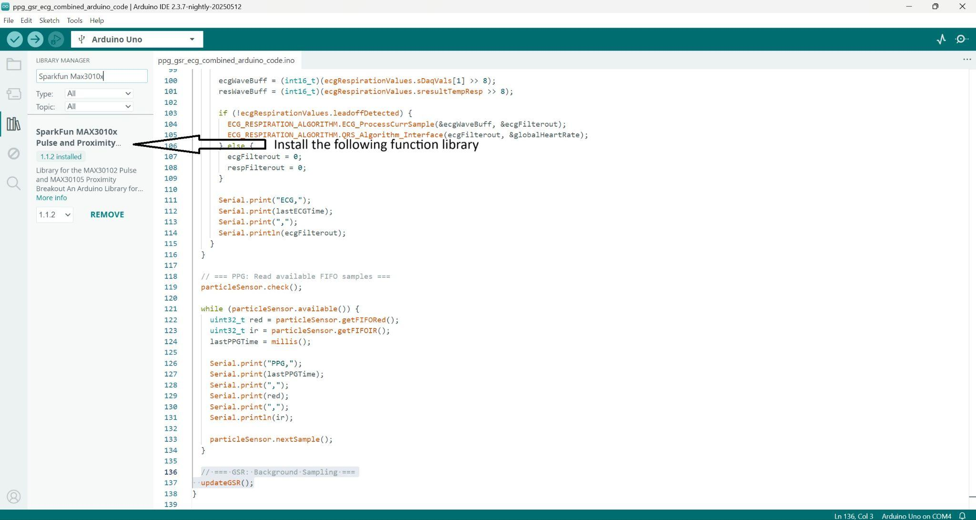
5. Press “install”
   1. This library should give you all the functions you need to run the ppg code.
6. Now for the second function library you need go to the same library manager search bar and type “ProtoCentral ADS1292R”.
7. You should see a library called “ProtoCentral ADS1292R ECG and Respiration”, as seen in the image below.
   1. 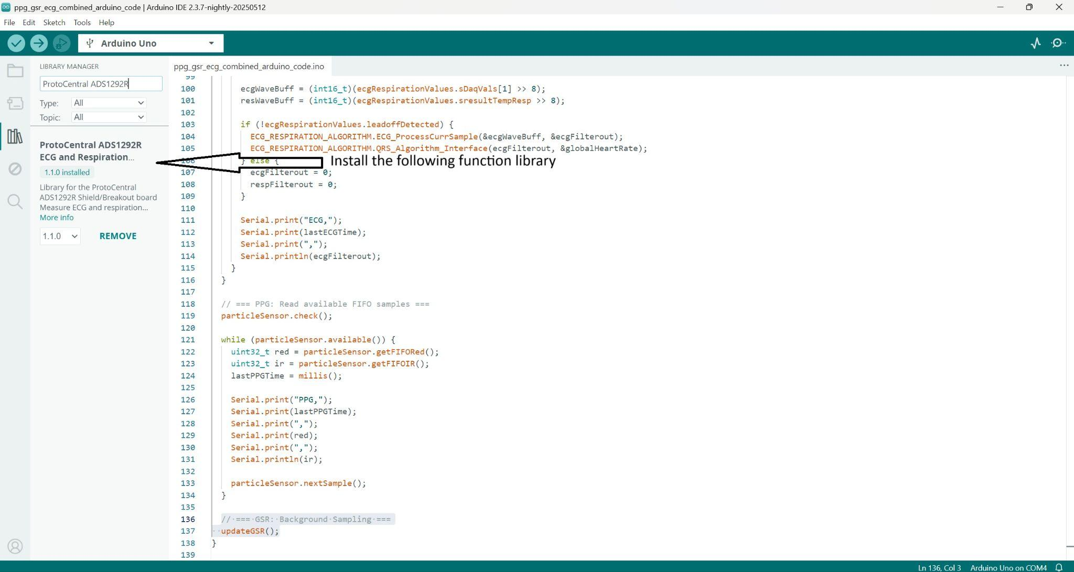
8. Press install.
   1. The following library should give you all the functions necessary to run all ecg related code.
9. No library is needed to run the GSR code.

Firmware repository:

1. ptt_testing_firmware_ecg_and_ppg_only
   1. The following code only needs the ecg and ppg board to work. This was the file used to troubleshoot, test, and validate PTT.
2. gsr_sensor_code_manufacturer
   1. The following code only outputs GSR data and is directly taken from the Seeed studio library.
   2. Seeed studio is the company that makes the GSR board
   3. Only minor modifications were made to the serial print of the code.
3. ppg_firmware_only
   1. The following code is only used to extract raw ppg data.
4. Finalized_ppg_ecg_gsr_firmware
   1. This code compiles all other firmwares in order to run the ecg, ppg, and gsr board simultaneously.